To our valued supporters of Makomborero Zimbabwe.

*Makomborero Zimbabwe Termly News*

1st Term 2022 Newsletter 34

This newsletter is to update you on the success of the 1st term 2022. We are very grateful for your contribution to Makomborero Zimbabwe and we look forward to a continued partnership. Please find below an update from our team in Harare.

From the Trustees of Makomborero Zimbabwe.

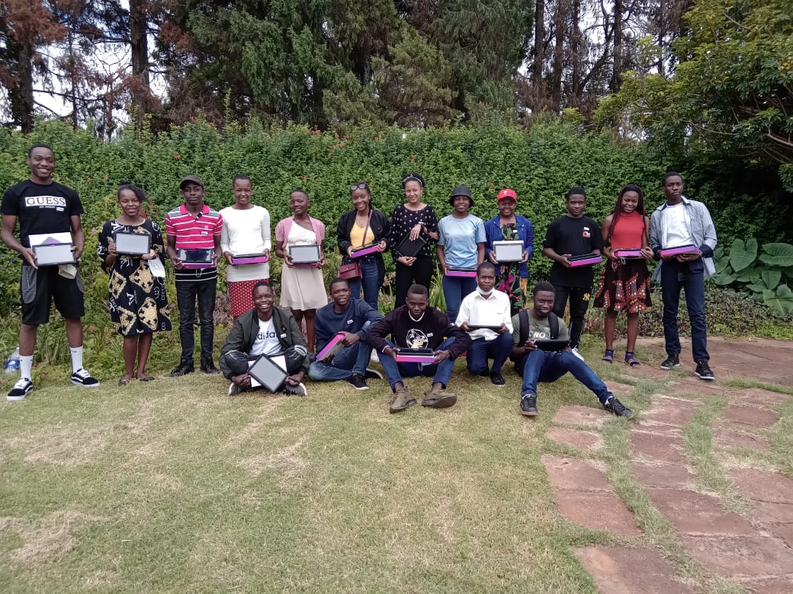**2022 begins with a few welcomes!**

We are so pleased to be able to start 2022 with you and to give you an update of the first term. We can’t believe we are in April already! This year we have welcomed 27 new students to the Makomborero family (10 Lower Sixth Internals and 17 Lower Sixth Externals). They have had a wonderful term of preparing for their A Levels, getting to know each other and attending Group Therapy sessions.

We have also welcomed our second intake of Gap Year students, Nicolle and Tanatswa. We are proud of them making the transition from being A’Level students to live-in Gap Year students. They have done an amazing job of assisting with the running of the boarding house as well as taking on tasks at the office. We want to take this opportunity to thank the kind donor who donated funds to build and kit out the Gap Year accomodation, now fondly known as ‘The Green House’. It’s a lovely and much needed addition to the boarding house.

Another warm welcome goes to our new House Mother, Mrs Tambowoneyi. She has had a wonderful start with the students and we are enjoying having her as part of the team!

**A Level students**

Our Upper Sixth Internal students started off with attending online lessons from mid-January. Face to face lessons started at the beginning of February for both Upper and Lower Sixth internal students. We are so proud of the Lower Sixes making the transition from their former schools to their current schools. Many of them have joined clubs and taken up sport keeping staff on their toes with school runs but definitely making us proud!

Our Upper Sixth external students also started attending face to face lessons later than usual, unfortunately without any online lessons prior to that. Our Lower Sixth external students have not attended lessons at all as O’Level results have just been released (mid-April) which is much later than the norm due to exams being written into January 2022. Lower Sixth external students are beginning to look for places to study their A’Level with the hope of starting lessons during the second term. Throughout the first term, the Makomborero team has been in contact with the Lower Sixth external students to encourage and equip them to make the best school choices.

We have been privileged to be able to offer Group Therapy sessions to all our Upper and Lower Sixth students as part of their Life Skills Sessions. External students travelled in on selected Saturdays and these sessions provided a great platform for them to get to know each other. We took the opportunity to use these Saturdays to give out helpful information on how to apply to universities and to give guidance on choosing schools for A’Levels. Mr and Mrs Albertyn gave out tablets and tips on how to maximise the use of these to the new Lower Sixth external students. Lots of fun was had throughout and the Easter Egg Hunt was a hit!

Internal students had their Group Therapy sessions during the week. Their Easter Egg Hunt was on the last Sunday of the term and the Albertyn’s had fun leading this together with the Gappies. We are so pleased to have been able to offer Group Therapy sessions to our students. It has changed their lives forever and helped them to make sense of some of their difficult pasts and backgrounds. We are very grateful to a kind donor who ensured we did not have to pay full price for the sessions otherwise we just would not have been able to afford them!

All Lower Sixth students had eye tests as part of their medical checks. These were heavily discounted by Specsavers who have supported us greatly over the years. We cannot thank them enough as these tests are another area where we see the lives of our incoming students changed. Of the 27 students, 8 needed glasses with one case being particularly bad.

**Examination results**

Under the most difficult circumstances, our students produced amazing results! We grinned, we jumped for joy, we did happy claps and we are still beaming with pride.

Our 10 A’Level Cambridge students had a collective of: 26A*, 9A and 4B

Our 10 AS Level Cambridge students had a collective of: 35A, 5B and 2C

Our 13 A’Level ZIMSEC students had a collective of: 25A, 10B, 5C, 3D and 2E

Our 27 Lower Sixth O’Level ZIMSEC results were as follows:

186A, 83B and 12C

One Lower Sixth student wrote Cambridge O’Level and his results were 7A*, 2A and 1B

***Special mention goes to:***

* Tanatswa outgoing Upper Sixth who was at Gateway High, achieved 5A* at A’Level
* Vitalis incoming Lower Sixth, from Goromonzi High School, achieved 16As at ZIMSEC O’Level
* Rufaro, incoming Lower Sixth, from St Faith’s High School, achieved 18As at ZIMSEC O’Level

Well done to each and every one of you! We are very much aware that you have not had anywhere near a normal two years! We are in awe of your strength and ability to cope with the difficult situations thrown at you. You inspire us!

**Class of 2021**

Our Class of 2021 has done a great job of keeping in touch and letting us know how they are doing. We have seen many of them find jobs as they wait for university offers which we look forward to celebrating soon.

**University students in Zimbabwe**

Our local university students started back earlier than usual to finish off exams that were pending from 2021 due to Covid-19. Exams were written over the months of January and February with the new semester starting in March. It gave most students little time to rest. We are proud of our students for embracing ths situation so well.

UZ fees have gone up three times over the months of March/April 2022 with most degree programmes now triple the price they were last semester. Most university students appreciate the stipends we give them as they would otherwise struggle to keep up with the cost of living and we in turn appreciate the donors who enable us to give out these stipends semester after semester.

We now have a total of thirteen students living at our University Residence, eight more students were welcomed to the house this year. They are a jolly bunch who can be heard singing and having lively debates. We have had some wonderful discussions where students have expressed how much they are enjoying staying in a clean, spacious and functional home! They are loving being able to pick from the variety of vegetables and fruit in the flourishing garden as well as playing games on the grounds and sitting in the gazebo. Our official opening is set for the month of April. We are eternally grateful to the donors of the house and to Beit Trust for providing this haven to our students and we look forward to celebrating together at the official opening.

**University students outside of Zimbabwe**

It’s always good to hear from our past Makomborero students and keep up with what they are doing in various parts of the world. Past students continue to mentor current students via the Alumni Mentorship Programme, another great way of keeping in touch and giving back.

**Other projects**

***The Girl Child Mentorship Programme*** began with a successful mentors’ breakfast where the focus was on inputting into the mentors and planning for the year ahead. Mentors were joined by Dr Bogezi from the Makomborero Zimbabwe board of trustees as well as our COO, Co-founder and Girl Child Programme visionary Mrs Albertyn. Both spoke on the value of being a mentor and what an essential part of the Makomborero family mentors are. The sessions with the mentees began shortly after with two schools to start with and the third school joining us a couple of weeks later. We are grateful that despite all the pressures the schools face, the selection process went well and we met 30 new girls for the first time this last term. They were excited to become mentees and are looking forward to spending the year with us. We closed the term with our usual Girl Child lunch. It was full of food, conversation and some much appreciated art therapy!

***The Mobile Science lab*** also started well. We are still recruiting below full capacity as we continue to be mindful of Covid-19. Students enjoyed getting involved in both Physics and Biology practicals, most for the very first time.

***Ndeipi!*** small business training was off to a great start! We had over twenty parents/guardians attend both meetings this term. We were pleased to be able to extend this training to Girl Child mentee parents/guardians for the first time with very pleasing results. The Ndeipi! participants learnt a lot in the first two sessions with some reporting they had started buying and selling after the first meeting and making small profits. We appreciate our continued partnership with One Hope Initiatives and we cannot wait to see and support the projects that will come from this year’s participants.

**A tribute to Dr Munyaradzi Clive Uchena**

On 12th February 2022, one of our pioneer students Dr Munya Uchena passed away in a tragic boating accident. The news was devastating to say the least. Here are some words of tribute from Mr and Mrs Albertyn:

‘Munya was a big brother, friend, mentor and son to us all at Makomborero. He encouraged and cheered many of us on through tough circumstances. He was dependable, hardworking and an inspiration to many. Gone too soon Munya! Our hearts are broken. We will remember you always. You left an imprint on many many hearts and we were so proud of you.’

**Thank you**

Thank you Gateway, Hellenic and St Georges staff for partnering with us and for all the hard work you sow into our internal students! Thank you to our government school teachers. We appreciate all the hard work you put into educating our external students. Without all of you, our students would not be able to produce such amazing results and we would not be able to ‘release’ such well-rounded human beings into the world. Thank you to each and every one of our sponsors and donors. Monetary donations, funding of specific projects, donations of stationery, food and clothes - without all these we simply would not stand. Thank you to those who pray, support and encourage us. We look forward to going through 2022 together!

**Proudly Sponsored by:**

******Description: http://profile.ak.fbcdn.net/hprofile-ak-snc4/50413_2221384168_3556757_n.jpg