To our valued supporters of Makomborero Zimbabwe.

*Makomborero Zimbabwe Termly News*

2nd Term 2022 Newsletter 35

This newsletter is to update you on the success of the 2nd term 2022. We are very grateful for your contribution to Makomborero Zimbabwe and we look forward to a continued partnership. Please find below an update from our team in Harare.

From the Trustees of Makomborero Zimbabwe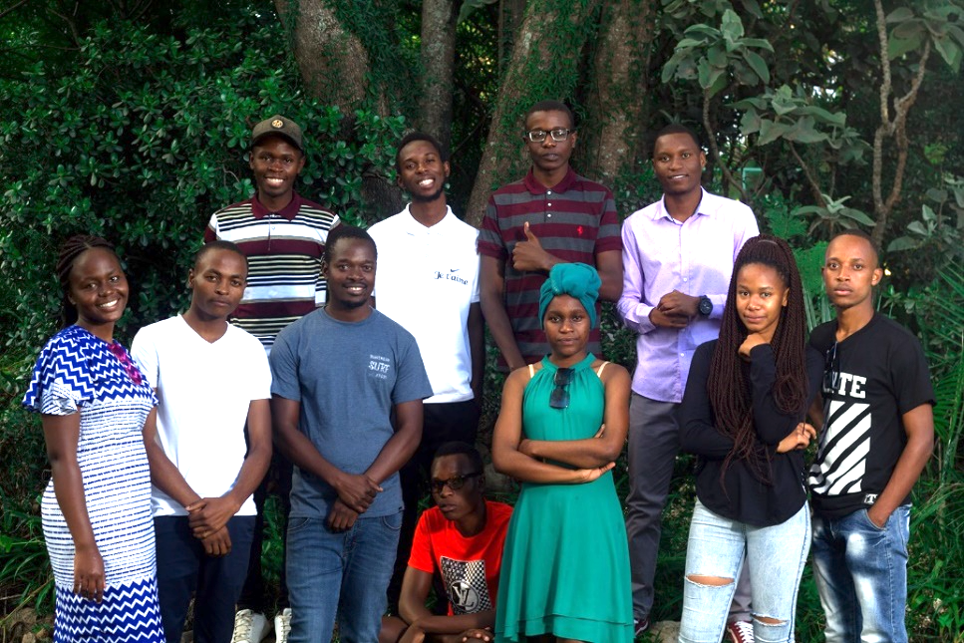

***Above: Some of the our past Makomborero students at the University Residence Official Opening event***

**Changing seasons**

The start of this second term continued to signal a welcome change from strict Covid-19 restrictions to more and more normal life. For this, we are very grateful! It’s been a wonderful term that has seen all our projects run well. Most students’ classes began when they were scheduled to and planned gatherings for our students were well attended. It was a term of exams all round and we are so proud of all our students for all they have achieved this term and for persevering through the harsh winter and numerous electricity power cuts. It was a biting May to July and I’m sure we speak for staff and students alike when we say we warmly welcome the change in season!

**A level Students**

Our external A-Level students were able to meet up on five occasions this term! They continued keenly with their Group Therapy sessions. These sessions make a huge impact on how students view and react to their world. For some of the meetings, we were able to give our external students donated books and clothes which were very well received. We love these meet-ups and the opportunities they give students to catch up with each other as well as for staff to have face to face check-ins with students! We are proud of our external Lower Sixth students who started back at school this term after their O’Level results came out. Many of them moved to new schools and are doing a great job of getting to grips with their new environments. Many are participating in sports such as volleyball, karate, netball and soccer. A few have joined clubs (chess seems a favourite) and it’s lovely to see the interest in youth empowerment clubs and clubs geared towards preserving the environment. Within these, nearly all students have been given positions of responsibility. There is a real positive vibe amongst our external students and they have made us smile with how they are spending weekends writing poetry, doing colour runs, reading, writing songs and growing vegetables.

Our internal students also had a great term this term! They benefited from weekly life skills sessions with Mrs Albertyn. They were able to go home and see their families during some of the weekends – which has not been possible for two years. When they stayed at the boarding house, our Gap year students helped us to ensure that lots of fun and relaxing was had. Africa Day was a particular hit. Students had a picnic on the grounds and played games for small prizes. In the evening they had a celebratory meal which included roasted chickens donated by a past Makomborero student. During the term, the tradition of sharing a few Sunday dinners with the Albertyns was upheld. Apart from eating together, Mr and Mrs A get to have lovely conversations and lots of fun with the students and both parties treasure these evenings. At their respective schools, many got involved in sport and extra-curricular activities which had staff doing school runs all days of the week, most hours of the day and many times during evenings. That said, we were happy to see so many of our students taking part and excelling in different activities!

We had a few occasions that brought both our internal and external students together. One of those was a Ndeipi entrepreneurship taster session which they all said they learnt a lot from. They are now looking forward to the annual camp due at the beginning of next term. The social aspect and togetherness of such occasions is always a huge hit!

**University Students**

Our university students have had a great term despite facing exams, some of which they found quite tough. Those who have settled at the recently opened University Residence have continued to see a huge change in the quality of their lives. We had the official opening of the house earlier in the term. It was a lovely occasion which united students, staff, board members and well-wishers!

As a goodbye to those who will be going to study abroad, Mr and Mrs Albertyn held a gathering for all alumni. It was a great afternoon of playing games, catching up with old friends as well as making new friends over doughnuts and tea. The timing was great for some of the alumni who were returning from various universities abroad for their holidays.

Similar to last semester, once fees had been paid, two more top ups were called for by all three local universities where our students attend. It goes without saying that this put a real strain on our budget and we are grateful to the donors who helped to rescue us on both occasions.

**2021 Leavers**

Well done to our 2021 leavers for all their achievements both academically and otherwise. They have made us so proud by taking on various gap year internships and volunteering at different organisations, including at Makomborero Zimbabwe. Others have taken initiative to gather donations for the less fortunate especially during the cold winter spell. Eight students have been accepted at universities outside of Zimbabwe and five have been accepted at local universities. We wish them all a fantastic journey through tertiary education. We believe in each and every one of you!

**Girl Child**

We have continued our Girl Child programme with the 30 mentees selected in January from the three different schools. Apart from a few chilly mornings, the turn out for sessions was great. It’s lovely to watch the mentees grow and make meaningful bonds with their mentors. They are all learning so much during their weekly sessions. We were proud of them using one of their sessions to pick up litter around their schools as a way of giving back to their communities. To close the term, we held our annual lunch which unifies all three schools. The girls had a fantastic talk from Mrs Albertyn and an informative session on oral hygiene. We are thankful for a generous donation which enabled us to send each girl away with a tube of toothpaste and a toothbrush.

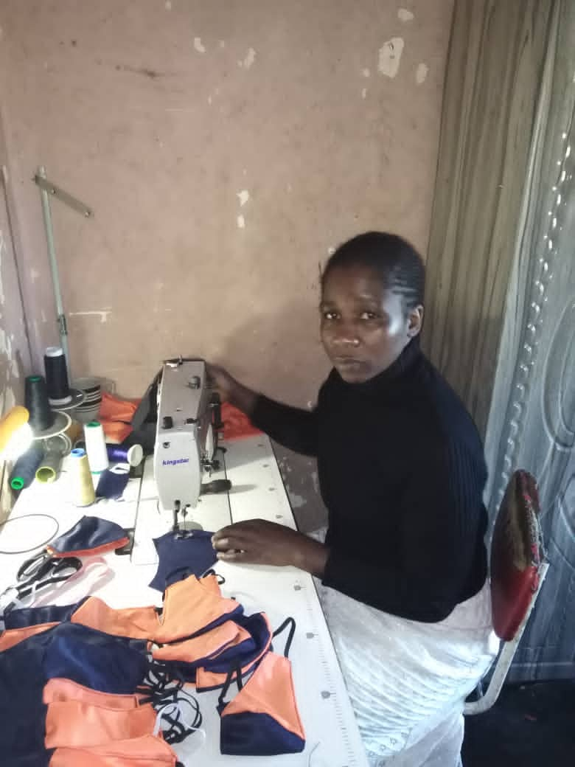

***Left: A Ndeipi participant making masks as a small business initiative***

**Ndeipi**

Ndeipi is our small business training. Our participants are recruited from students’ parents and guardians and for the first time, this year we recruited from parents and guardians of our Girl Child mentees. What an amazing term we have had at Ndeipi! Attendance was great and participants made good progress with their small business initiatives. We had reports of some lovely projects that have been started between last term and this term. We had a donation of some baby clothes and we were able to make bags of about 8 items each for each participant to sell at a profit. This was a great ‘beginner’s project’ for many who did not know where to start.

**Mobile Science Lab**

Our Mobile Science lab has had a very encouraging run this term. We erred on the side of caution and once again recruited below full capacity due to lingering Covid restriction. We were impressed by this term’s very enthusiastic students who had a high turn-out rate each week. Once again, generous donations meant that we were able to purchase some new equipment for Physics practicals and the students thoroughly enjoyed using these!

**Mutsidzira**

Mutsidzira is an annual community grant that invites past Makomborero students to apply for financial help in order to fund their proposed projects. This year the grant was won by a peanut butter making project set to assist a small community in Buhera with putting children through education from the profits. We are excited to see this project develop and encouraged by two of the 2021 projects that are still running.

**Alumni mentoring**

Our Alumni mentorship continues to grow with past Makomborero students mentoring current Makomborero students. We appreciate all the hard work and time that past Makomborero students invest into this project and look forward to all their exciting ideas coming to fruition!

**Thank you**

Thank you to our staff and volunteers for all the time and effort you put into making this term such a wonderful term. We value being family, working through the challenges together and celebrating the highs together.

We would like to thank our Mobile Science Lab teacher Tongai who served students from 2015 up to the end of term 2, 2022. Thank you for all you invested into our young people Tongai and we wish you all the best for the future!

Thank you to Tanatswa for all you invested as one of our 2022 Gap Year students. Tanatswa is leaving his post a little early to go to university! We wish him all the best. We welcome Ropa who will be taking over for the remaining few months.

Thank you to our partner schools Gateway, Hellenic and St Georges. We are humbled to be able to continue to partner with you and grateful for all the work you pour into our students. Thank you to all teachers and heads of schools where our external students attend. You continue to produce well-rounded young men and women under exceptional circumstances and we are truly grateful.

Last but not least, thank you to our individual and corporate sponsors! You make a huge difference in the day to day lives of our students whether you are donating stationery, food, clothes or money. Like any other term, it would have been impossible to make it through Term 2, 2022 without you! We deeply appreciate you all!

**Proudly Sponsored by:**

******Description: http://profile.ak.fbcdn.net/hprofile-ak-snc4/50413_2221384168_3556757_n.jpg